TC-DM-002
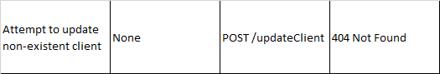
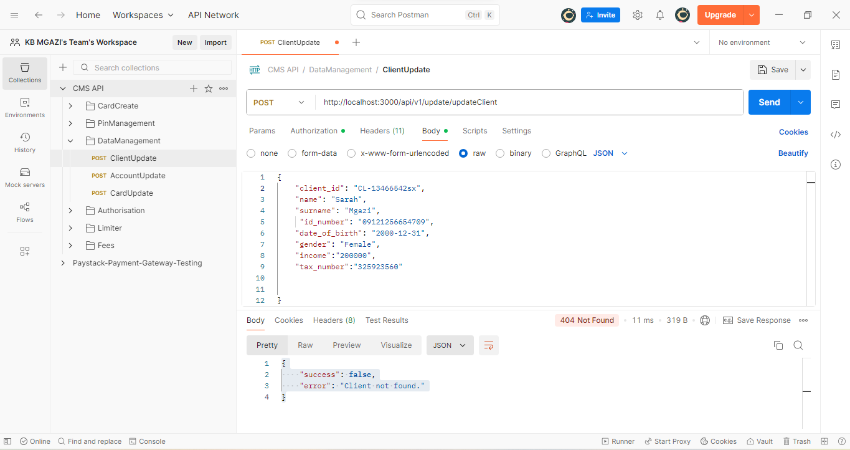
Request :
{
"client_id": "CL-13466542sx",
"name": "Sarah",
"surname": "Mgazi",
"id_number": "09121256654709",
"date_of_birth": "2000-12-31",
"gender": "Female",
"income":"200000",
"tax_number":"325923560"

}

Response:
{
"success": false,
"error": "Client not found."
}

